BIG DATA LAB

Name:S.L.A.Laisha

USN:1NT19IS147

SEC:C1

Date: 10-05-2022

Insert data

>db.Data.insertMany([{"Name":"Rani","age":22,"gender":"F"},{"Name":"Mohan","age":20,"gender":"F"}, {"Name":"Sita","age":21,"gender":"F"}])

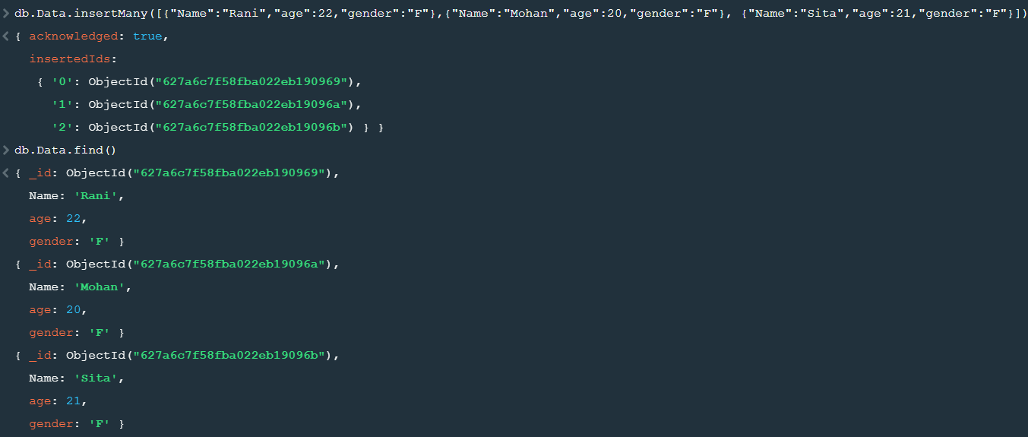

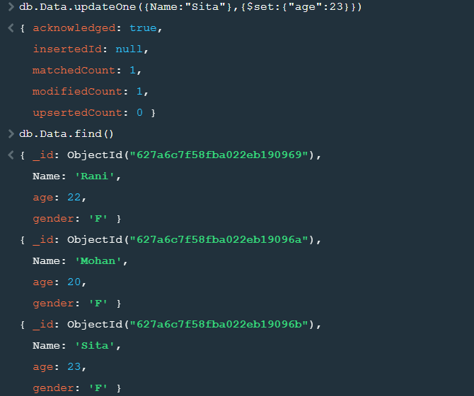

MAP REDUCE FUNCTIONS

AVERAGE:

>var map=function(){emit(this.name,this.age)};

>var reduce=function(name,age){return Array.avg(age);};

>db.Data.mapReduce(map,reduce,{out:”newcollection”});

>db.newcollection.find()

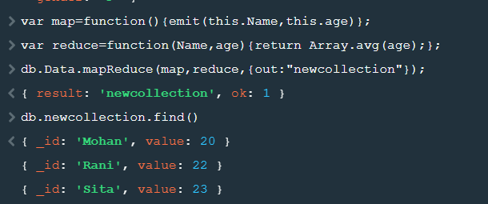

SUM:

>var map=function(){emit(this.name,this.age)};

>var reduce=function(name,age){return Array.avg(age);};

>db.Data.mapReduce(map,reduce,{out:”newcollection”});

>db.newcollection.find()

